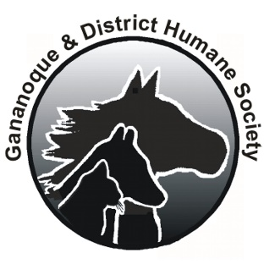
Gananoque & District Humane Society
85 Highway 32, RR#1 Gananoque, Ontario, K7G 2V3
Tel: 613-382-1512 Fax: 613-382-0333

“FRIEND FOR LIFE” MONTHLY DONATION AUTHORIZATION

I AUTHORIZE THE GANANOQUE AND DISTRICT HUMANE SOCIETY TO DEDUCT THE FOLLOWING AMOUNT FROM MY BANK ACCOUNT AUTOMATICALLY ON THE 15TH OF EACH MONTH.

$10.00 $25.00 $50.00 $100.00 Other amount _____________________

Please print the following information.

NAME: ___________________________________________________________________________

ADDRESS: ________________________________________________________________________

POSTAL CODE: __________________________TELEPHONE: _____________________________

EMAIL ADDRESS: __________________________________________________________________

I HAVE ENCLOSED A BLANK CHEQUE MARKED “VOID”

SIGNATURE: ___________________________________________DATE: _________________________

- Please mail this signed form and your blank “Void” cheque to the Gananoque and District Humane Society at the address above in a confidential envelope to the attention of “Treasurer”
- To make any changes in your monthly authorization please advise us by regular mail, fax or email (humanesociety@bellnet.ca) by the 20th of the month BEFORE the change is to be effective. e.g. To make a change effective on Sept 15th, we need to know by August 20th.
- All identifying or personal information you provide will be kept secure within the confidential records of the Gananoque and District Humane Society and will not be released to anyone except as authorized by you for the purposes of carrying out your instructions or as required by law.
- Under no circumstances will your personal information be sold, rented or loaned to anyone.

Authorization to communicate:

I authorize the Gananoque and District Humane Society (Humane Society) to use my contact information to keep me informed of events sponsored by the Humane Society, special needs or other information that I may find of interest. I may withdraw this authorization at any time by advising the Humane Society in writing.

Signature: ______________________________________________DATE: _________________________
(This authorization must be signed separately)
Last updated Aug 2, 2019

